**SESSION-1**

Version Control System(VCS):

Two type –

1. Centralized VCS
2. 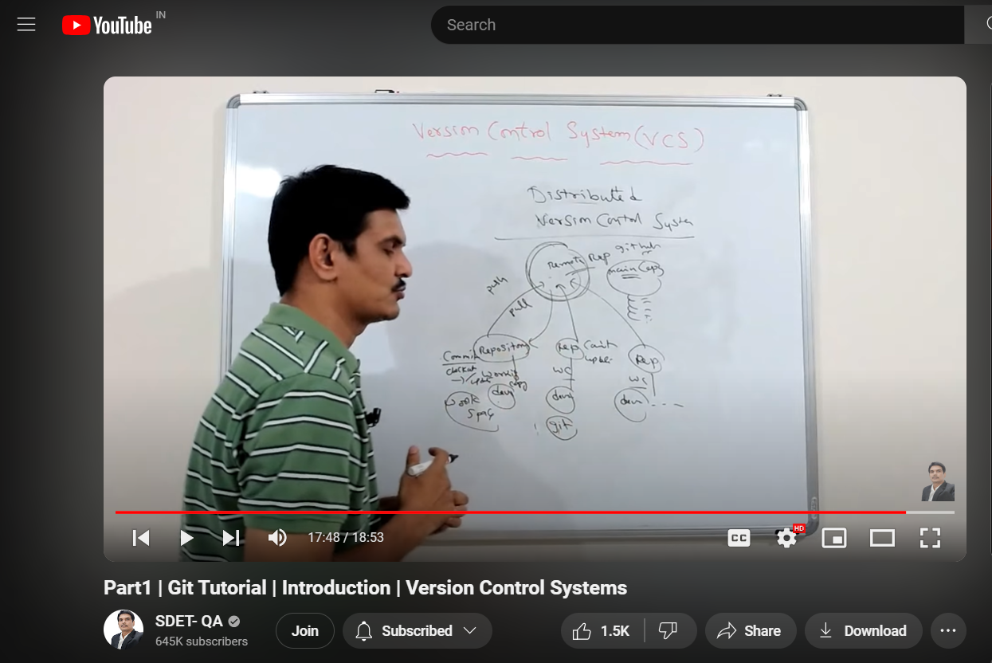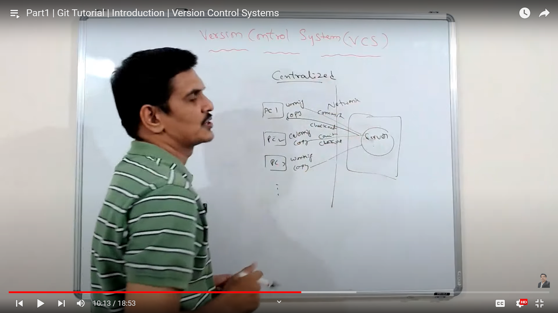Distributed VCS

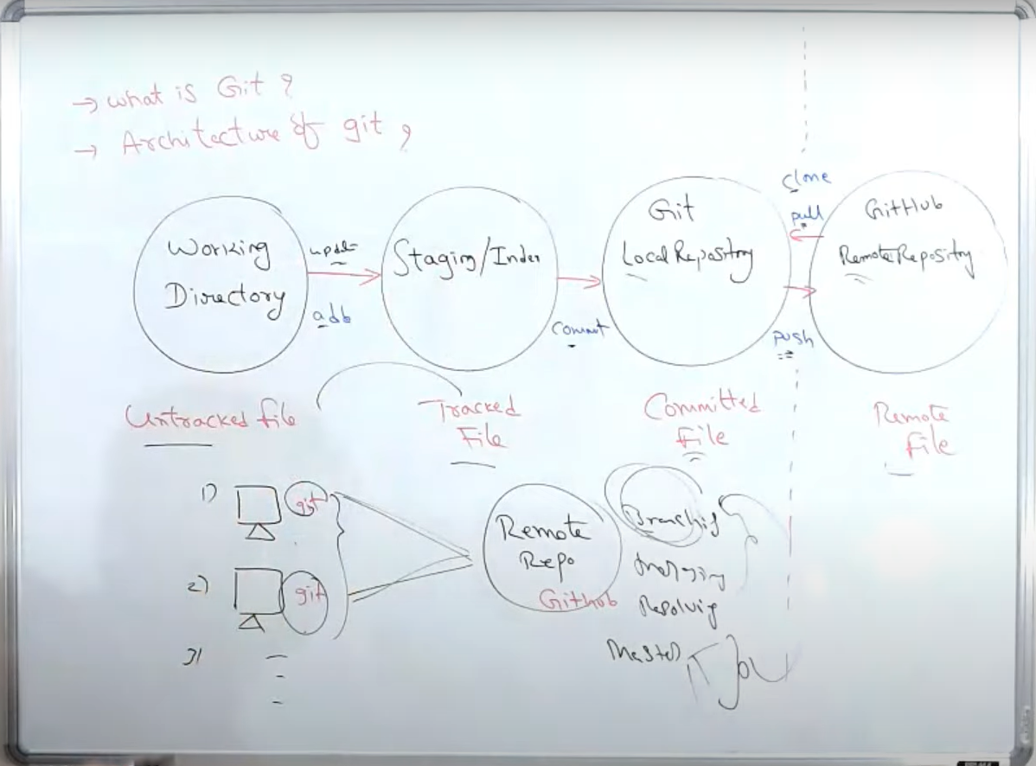**SESSION-2**

**Git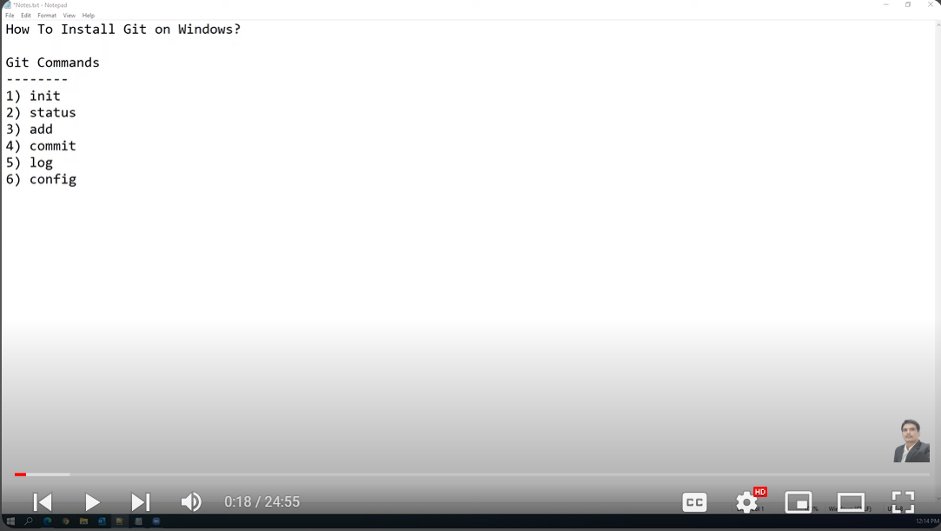 SESSION-3**

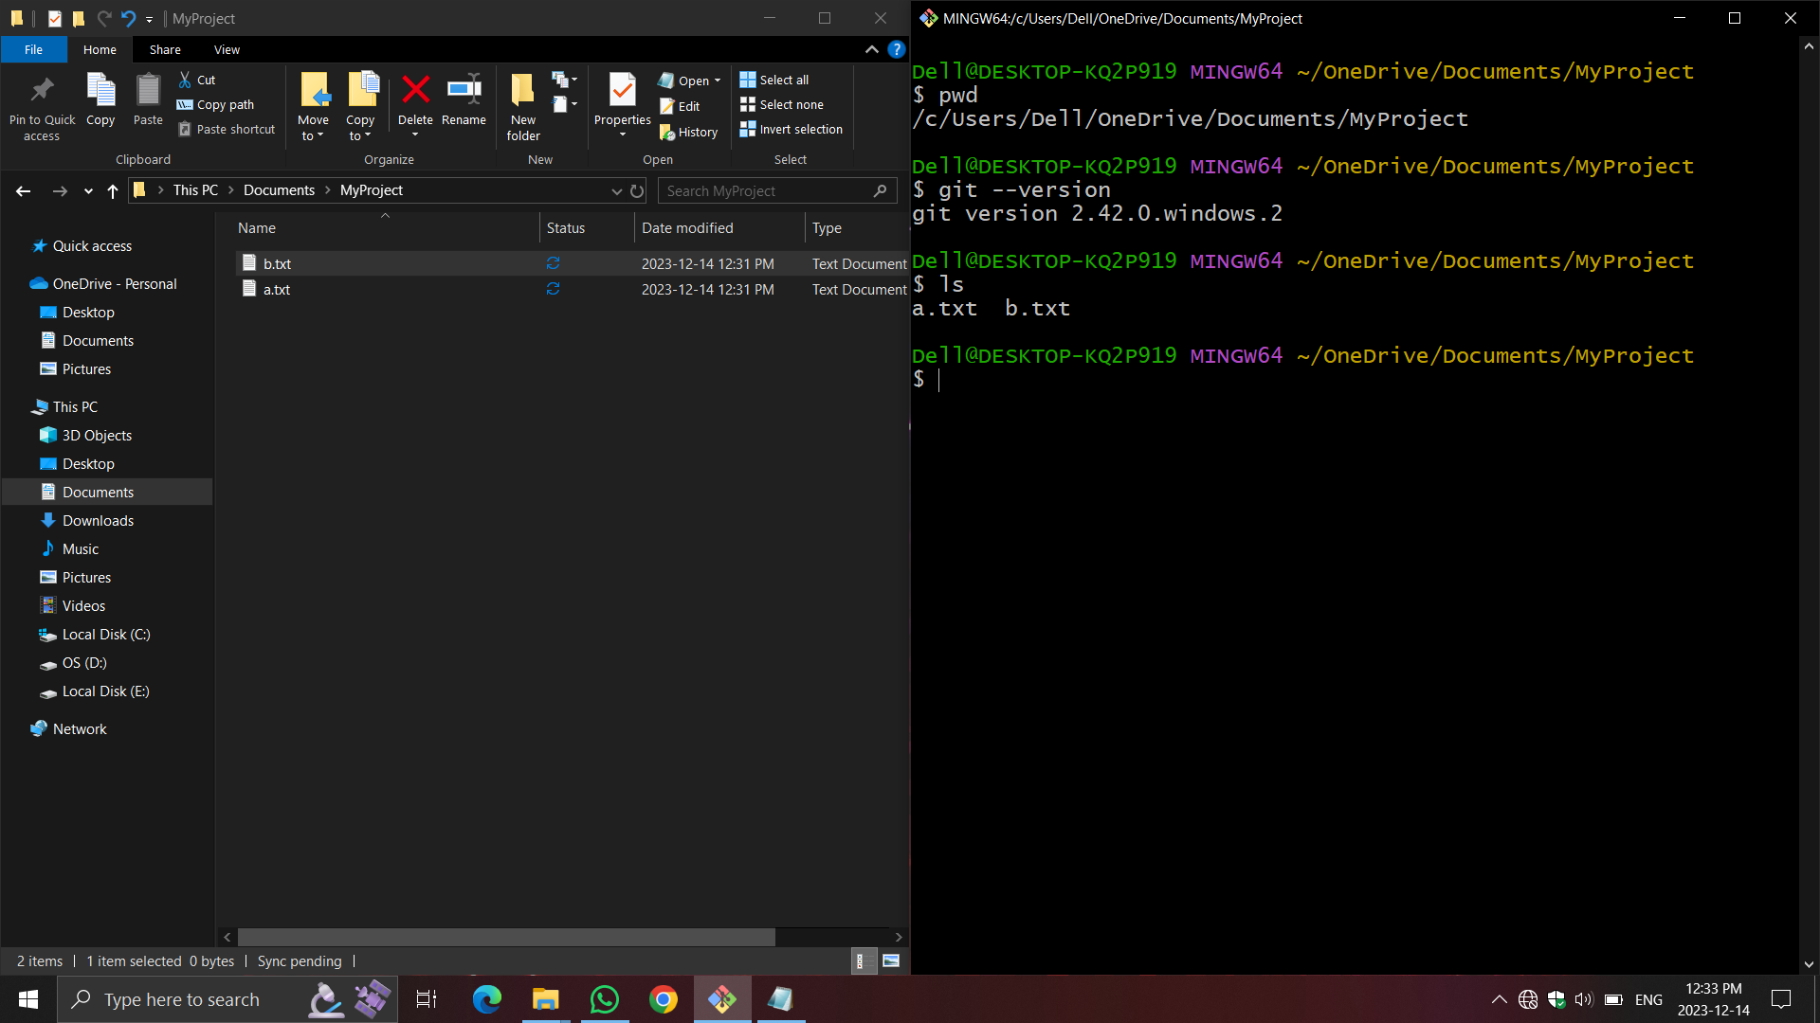To show current working directory ,git version and folder files:-

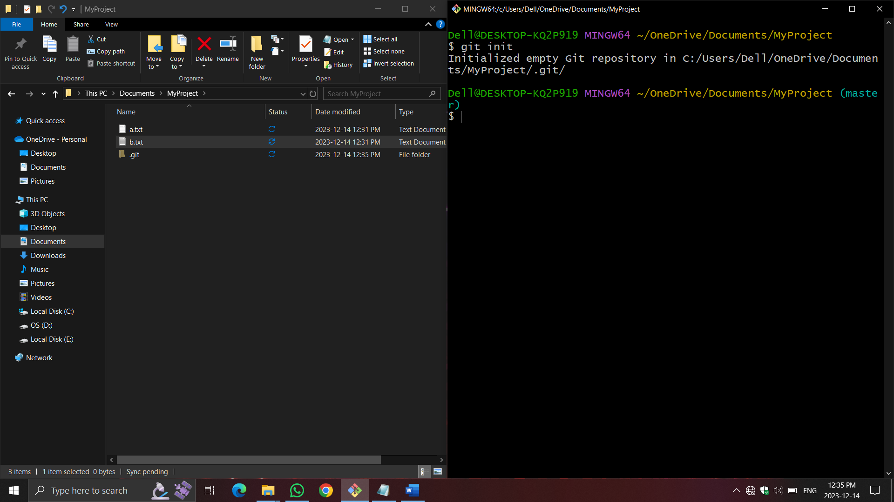To initialized a folder as a local repository -

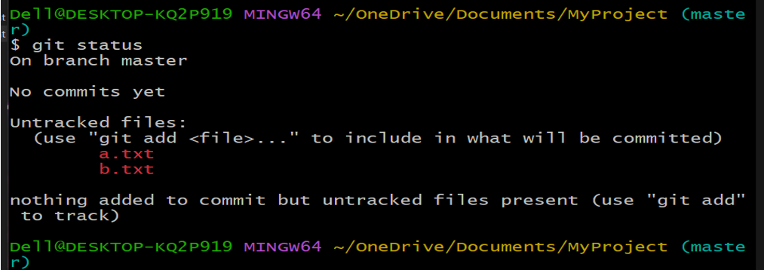To show status of the repository -

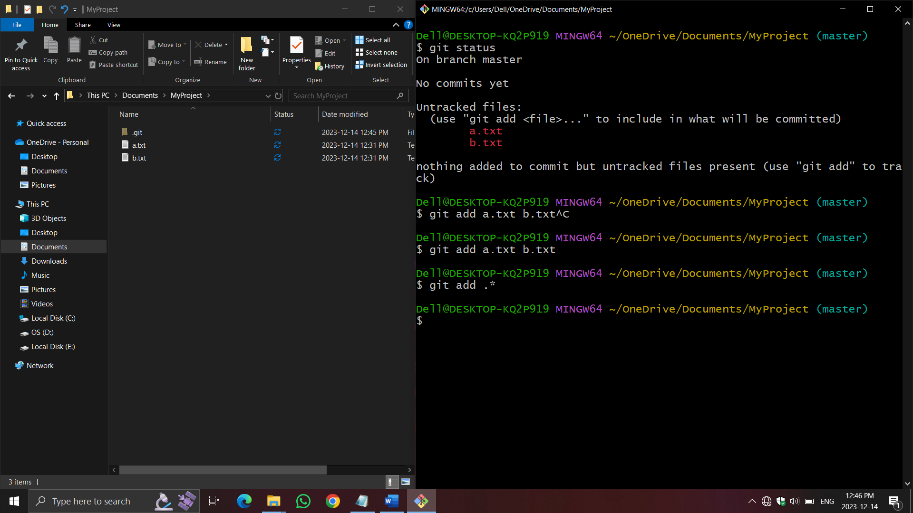To add the file from folder to local repository -

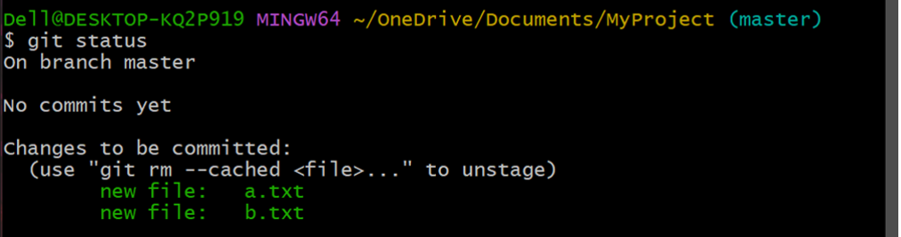Show the status of repository after adding the files –

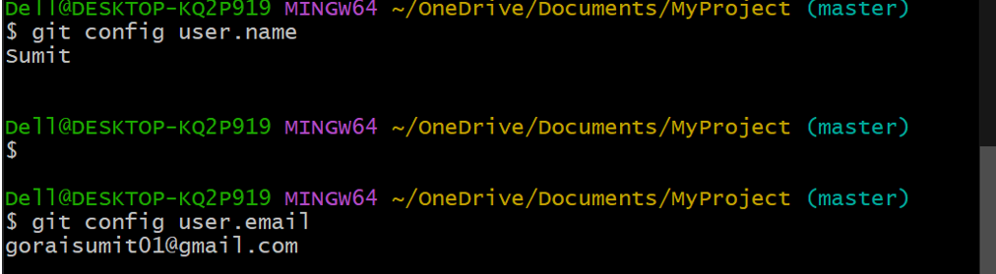To add username and email when install first time the git software this is done only once –

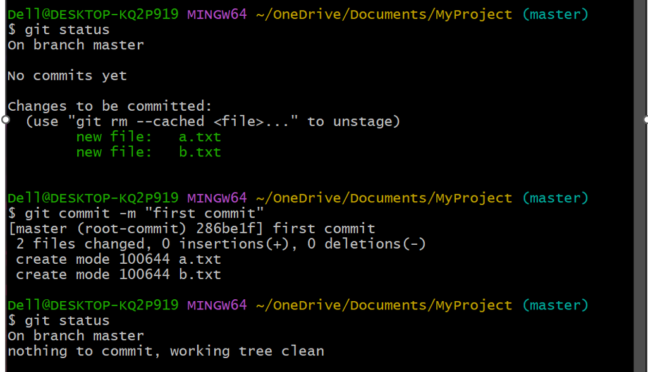To commit the files -

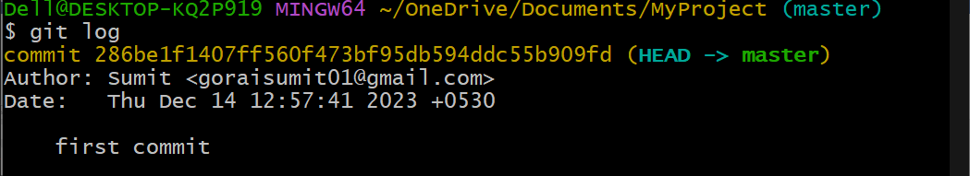To show the history of commit -

If the files are modified then how to commit , this is shown below -

